Now we willl talk about basic styling in React Native
and you know the saing ki jo dikhta hain wo bikta hain
You may use any strong logic in your application
If your UI is not good everything is broken then nobody will like your application whehter you have used very strong logic but it does not have any benefit if itsd UI is not decent
So atleast we should know basic stylking in any technology
Now here we are talking about React Native
So in this lesson we will see basic style in react native
In upcoming lesson we will go to advanced styling and also go to animation and will learn everything but for now just basic

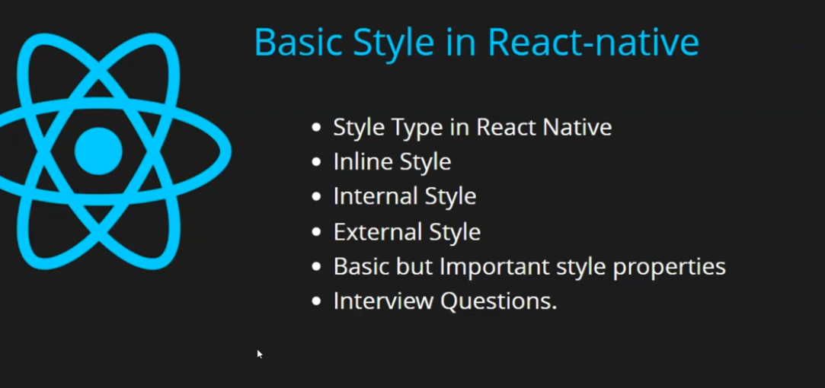

So firstly techer will tell us wayus you can do styling in react native

They are
- Inline
- Internal
- External
Teacher will show us example of all
The properties we are going to learn are basic but very important
whenver you style in your application then at least use these property
So will learn a lot here
In last we will cover some interview question
For now our code will belike below

function App() {
const [age,changeAge] = useState(22)

return (
<View>
<Text>Style in react Native </Text>
</View>
);
}

For now we have just taken some View and text
Output:-

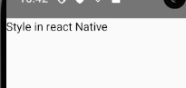
Now we startt with inline style
Where inline style is used
when we take a component
You know in context of React native we call tag as Component
Whatever style we are doing inside component we call it inline style
it is used in the opening tag of the component like a prop or an attribute named as style we pass it double opening and closed curly bracked The outside is for javascript and inside is for showing an object
The style in react native are almost similar to the like
In web we use font-size
similarly for mobile(React native) we use fontSize in camel case and if you give it value after colon then pixel are not used here as a unit it is just a normal value
you would not need pixels normally here
So we use Fontsize and set it to 30 so here is the code aand output

<View>
<Text style={{fontSize:30}}>Style in react Native </Text>
</View>


Now what is we want ot add more style here

like color then it will be like below
<View>
<Text style={{fontSize:30,color:'red'}}>Style in react Native </Text>
</View>

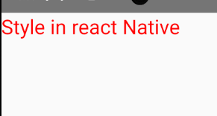
So we can add another style by adding , and seperating both the styles as shown in above code
So this was our inline css

Note:-
The fast refresh makes the app updated when you click save the file in your editor
you can enable or disbale it by ctrl + m in your emulator and then click on Enable/Disable Fast Fresh
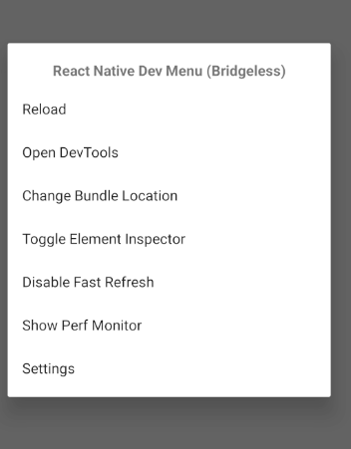
Now we will see internal css
Any style that you make for a component or make it inside a file
We call it internal style
Now suppose we have four text and all of them have same style as shown below

<Text style={{fontSize:30,color:'red',backgroundColor:'green'}}>Style in react Native </Text>
<Text style={{fontSize:30,color:'red'}}>Style in react Native </Text>
<Text style={{fontSize:30,color:'red'}}>Style in react Native </Text>
<Text style={{fontSize:30,color:'red'}}>Style in react Native </Text>

but first text ahve different bg as shown below becuase of Background style property

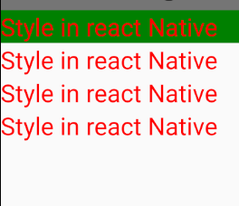
bit we want it to apply now in all
but don't youthink it is weird that if we are repeating the style then it should be common code to reduce redundanncy So fot that inside a component file we use internal style
No for that you need to import from react-native as shown below
import {Button, Text, View,StyleSheet} from 'react-native';

Now how to use it
Use it after the end of the component or before the component
It will be bettrer if you is outside the component
So take a normal const and assign itan object returned by
StyleSheet.create method inside and now inside its argument pass the object
having its custom key and value and each key has a seperate style object
as shoen below
const styles = StyleSheet.create({
textBox:{
color:'blue',
}
})

so we make a key textBox and give it style now to apply it inside a component
Go to that component and in style attrinute pass the styles const object you made and then access the customkey we made that is textBox
as shown below
<Text style={styles.textBox}>Style in react Native </Text>

We applied it to the second text so output will be like below

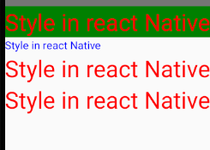
we can similarly apply it oother component as well
5:20
Now we increase the font size in textBox as shown in code

const styles = StyleSheet.create({
textBox:{
color:'blue',
fontSize:30
}
})

now we can use this styles.textBox to attach same style different compnent

Now we add background color and also bottom margin

const styles = StyleSheet.create({
textBox:{
color:'blue',
fontSize:30,
backgroundColor:'lightblue',
marginBottom:10
}
})

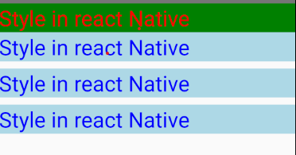
Now can see the light blur bg and 10 size bottom margin

You can also add padding
const styles = StyleSheet.create({
textBox:{
color:'blue',
fontSize:30,
backgroundColor:'lightblue',
marginBottom:10,
padding: 10
}
})

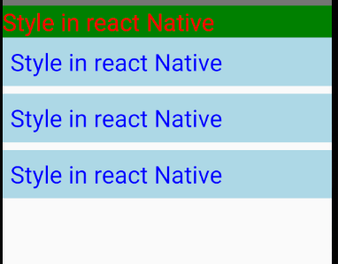

You can also use property borderRadius : 10

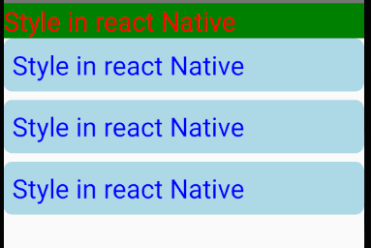

You can laos increase height by 100

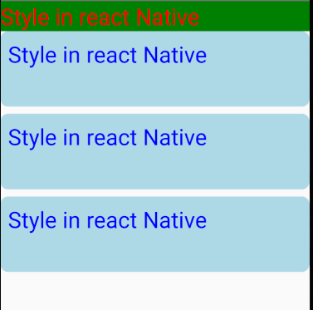

Now to make the text come n the center of the box first we align it in center vertically
By
textAlignVertical:’center’
And then horizontally by
textAlign: ‘center‘

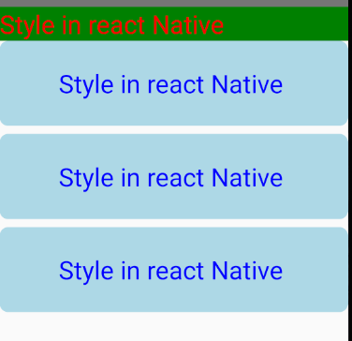

We can set its Border color by
borderColor:’red’ but before we set its width by
borderWidth:2
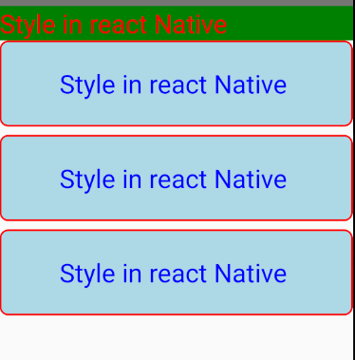

const styles = StyleSheet.create({
textBox:{
color:'blue',
fontSize:30,
backgroundColor:'lightblue',
marginBottom:10,
borderRadius:10,
height:100,
textAlignVertical:'center',
textAlign:'center',
borderColor:'red',
borderWidth:2,
padding: 10
}
})

Now this is internal style for us now
It was a question of one component what if there are 20 components then you will not want to paste it in every component
Ideal situation should be we should kept it outside in a separate file so that we can use it in different different component
Foe that we do external style
For that we create a new file and we can name it as anything for no we name it as style.js
And inside it we first import the Stylesheet and then create our style like below

import { StyleSheet } from "react-native";
export default exStyles = StyleSheet.create({
textBox:{
color:'#ffffff',
fontSize:50,
backgroundColor:'red',

}})

And then export it default and then import it in the component you want to use it in
And now to test It we add a new text element and apply this style there

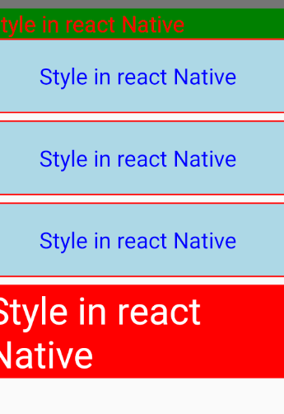
It is often asked to apply multiple style on an element like we add multiple class to an elemtn in html
by enclosing the different style in the array
as shown below
<Text style={[styles.textBox,exStyles.textBox]}>Style in react Native </Text>
The style that comes fierst in the array will be applied first and then later other will follow on
So we add another Text and the emulator result is as follows
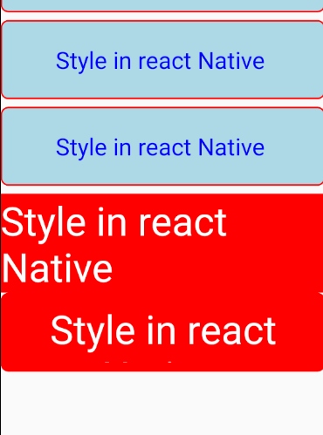
Now if we swap the styles in the array then it will be like this
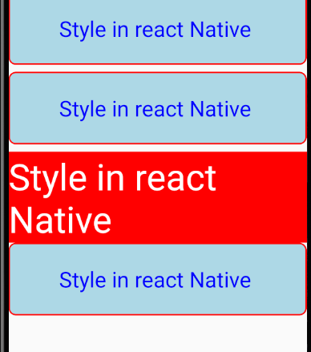

You can also add another inline style here by making it a member of the array and enclose it in curly brackets like you do in inline
Example

<Text style={[exStyles.textBox,styles.textBox,{marginTop:10}]}>Style in react Native </Text>

We add inline of top margin so now our output will be like below
The style will be applied from first element to last element in style

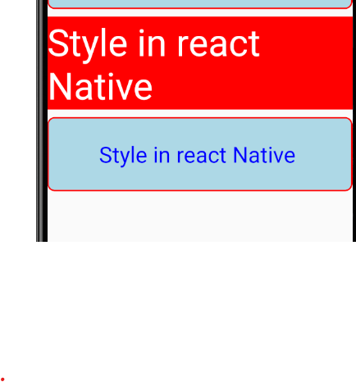
13:00

According to teacher we have seen many things
We have learnt how to do things in center (Horizontally and vertically) give border and how to manage radius border
We have learnt everything

